- The schedule details created before closing the previous month (March – schedule No-3).

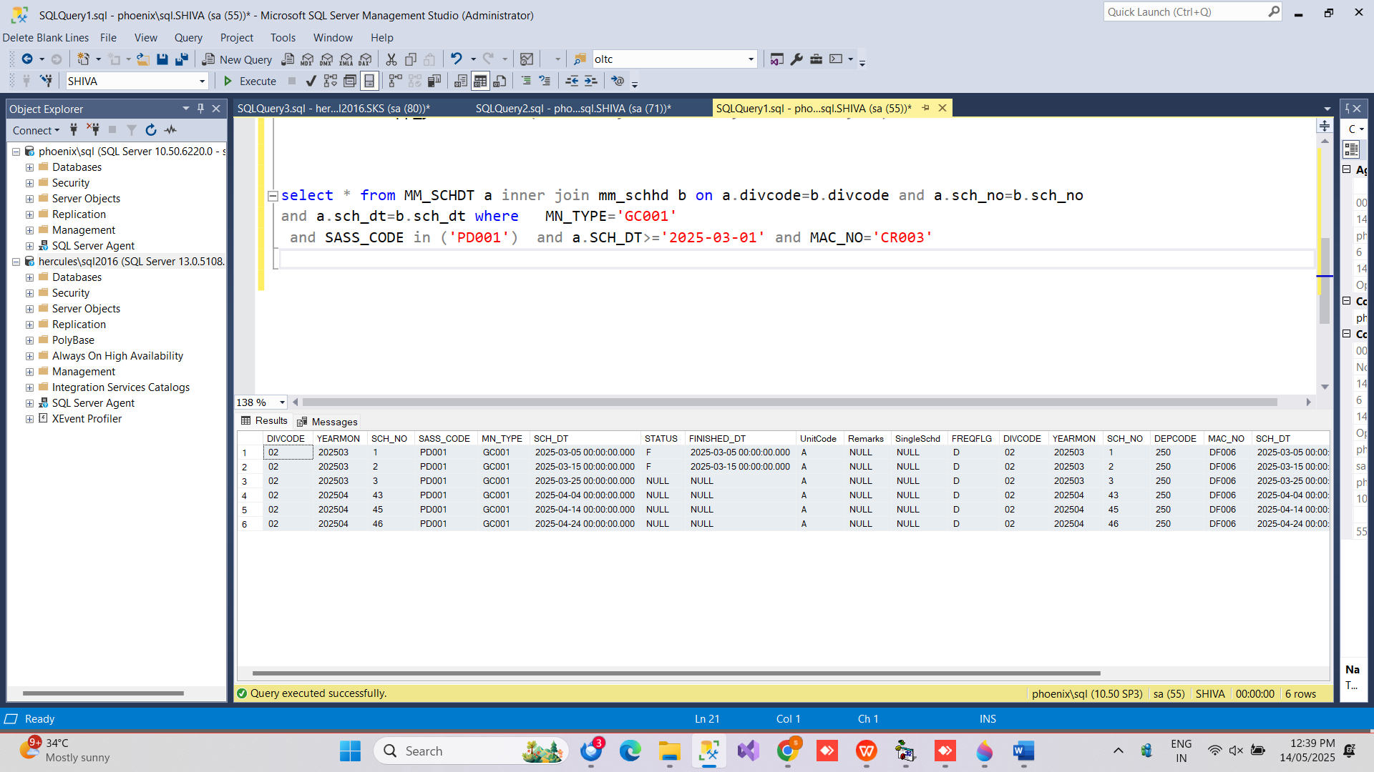

- Jobcard completed for the schedule Number-3 in the finishing date of 13-Apr-2025.

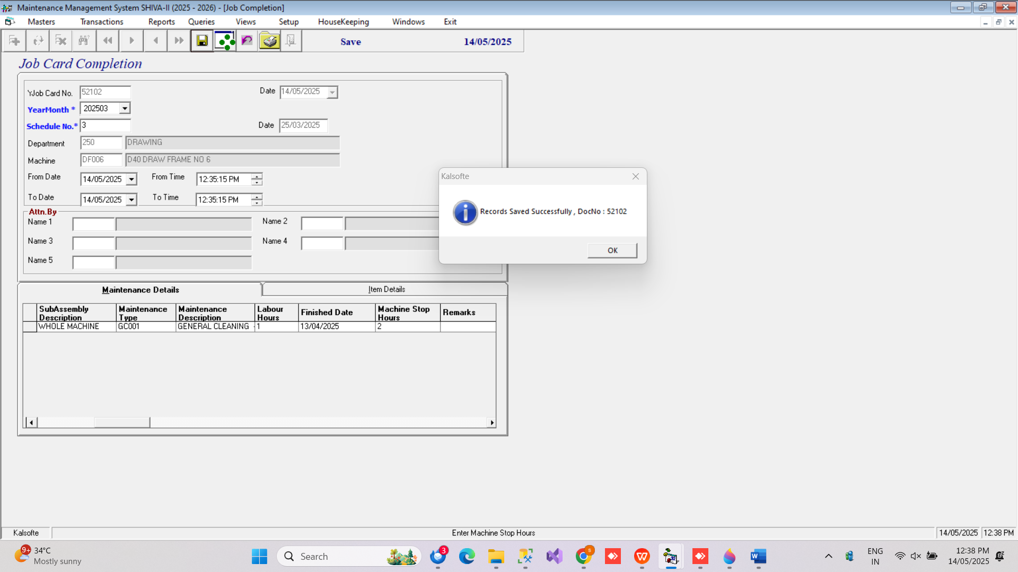

- After complete the schedule number 3, the following previous schedule details are not deleted , new schedule generated ( SchNo: 43 - Date: 23-Apr-2025 ).

